MERGING JOINING DATA
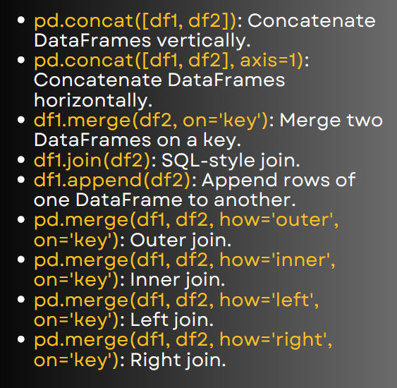

1. Concatenate vertically (stack rows)
import pandas as pd
df1 = pd.DataFrame({'A':[1,2], 'B':[3,4]})
df2 = pd.DataFrame({'A':[5,6], 'B':[7,8]})
result = pd.concat([df1, df2])
print(result)

Output
A B
0 1 3
1 2 4
0 5 7
1 6 8

2. Concatenate horizontally (side by side)
result = pd.concat([df1, df2], axis=1)
print(result)
Output
A B A B
0 1 3 5 7
1 2 4 6 8
3. Merge on a key (like SQL INNER JOIN default)
df1 = pd.DataFrame({'id':[1,2,3], 'name':['A','B','C']})
df2 = pd.DataFrame({'id':[1,2,4], 'age':[21,22,23]})
result = df1.merge(df2, on='id')
print(result)

Output
id name age
0 1 A 21
1 2 B 22

4. Join (shortcut for index-based joins)
df1 = pd.DataFrame({'name':['A','B','C']}, index=[1,2,3])
df2 = pd.DataFrame({'age':[21,22,23]}, index=[1,2,4])
result = df1.join(df2)
print(result)

Output
name age
1 A 21.0
2 B 22.0
3 C NaN

5. Append rows
df1 = pd.DataFrame({'A':[1,2]})
df2 = pd.DataFrame({'A':[3,4]})

result = df1.append(df2)
print(result)
Output
A
0 1
1 2
0 3
1 4
append() is deprecated → better to use pd.concat([df1, df2]).

6. Outer join (all rows, fill missing with NaN)
result = pd.merge(df1, df2, how='outer', on='id')
print(result)
Output
id name age
0 1 A 21.0
1 2 B 22.0
2 3 C NaN
3 4 NaN 23.0

7. Inner join (only common rows)
result = pd.merge(df1, df2, how='inner', on='id')
print(result)
Output
id name age
0 1 A 21
1 2 B 22

8. Left join (keep all from left, match right if exists)
result = pd.merge(df1, df2, how='left', on='id')
print(result)
Output
id name age
0 1 A 21.0
1 2 B 22.0
2 3 C NaN

9. Right join (keep all from right, match left if exists)
result = pd.merge(df1, df2, how='right', on='id')
print(result)

Output
id name age
0 1 A 21
1 2 B 22
2 4 NaN 23

